**Development process for Laffy Taffy Joke Page Creation**

1. First we need to create a custom plugin for api run and we can get it from here- <https://drive.google.com/drive/folders/1wB2wrKozO_NQGp1yaKuQhn7V8FPGX-KI?usp=share_link>

1. After add custom plugin go to extend and enable or active custom plugin model from admin section of drupal site

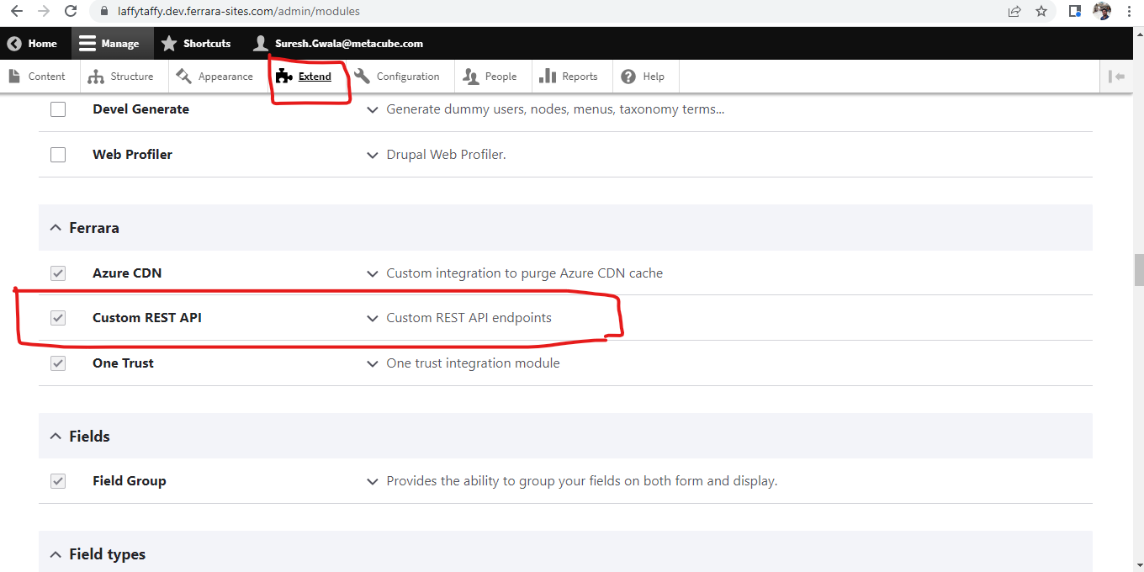

1. After Enable custom plugin from extend page then go to the configuration section to enter access credentials of api which provide help for getting data from client’s server.

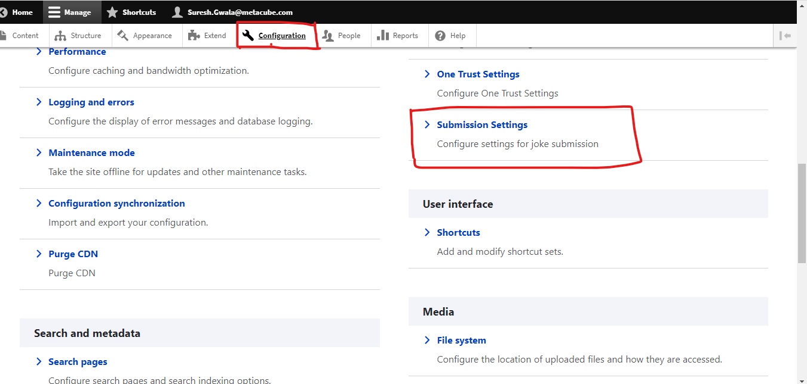

1. After click on the Submission Setting option you need to add all useful credentials for setting up custom api with client section like below screenshots.

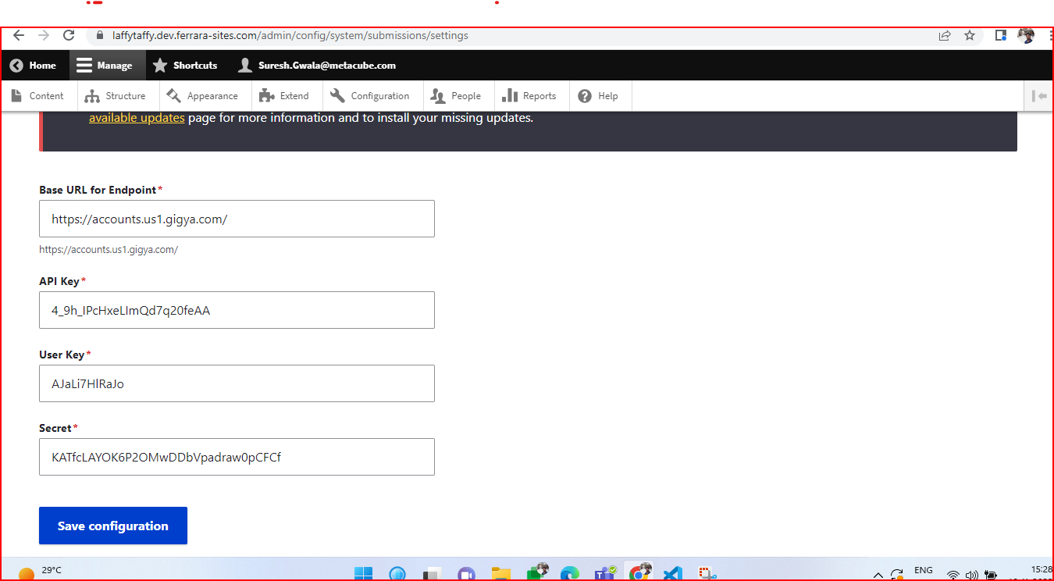

1. After adding the details in the settings page we have to Enable the api options from the web services page.
2. Below screen shot we have two modules which are listed in extend page, if we don't have that module in our system we have to install them using composer command or we can add them manually using the’ https://drupal.org’ site. We have to check how to add contribe module in extend page using this link - <https://www.drupal.org/docs/user_guide/en/extend-module-install.html>

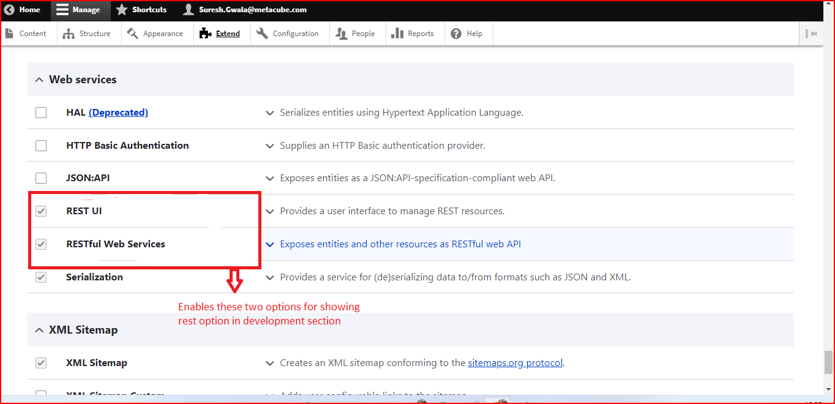

**Activated these two options to get below image’s option in configuration link.**

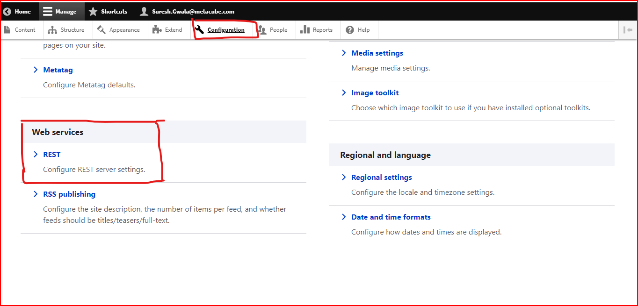

1. After clicking on the Rest option we have to enable the Joke Resource from the list and then will edit the setting options for our api progress.

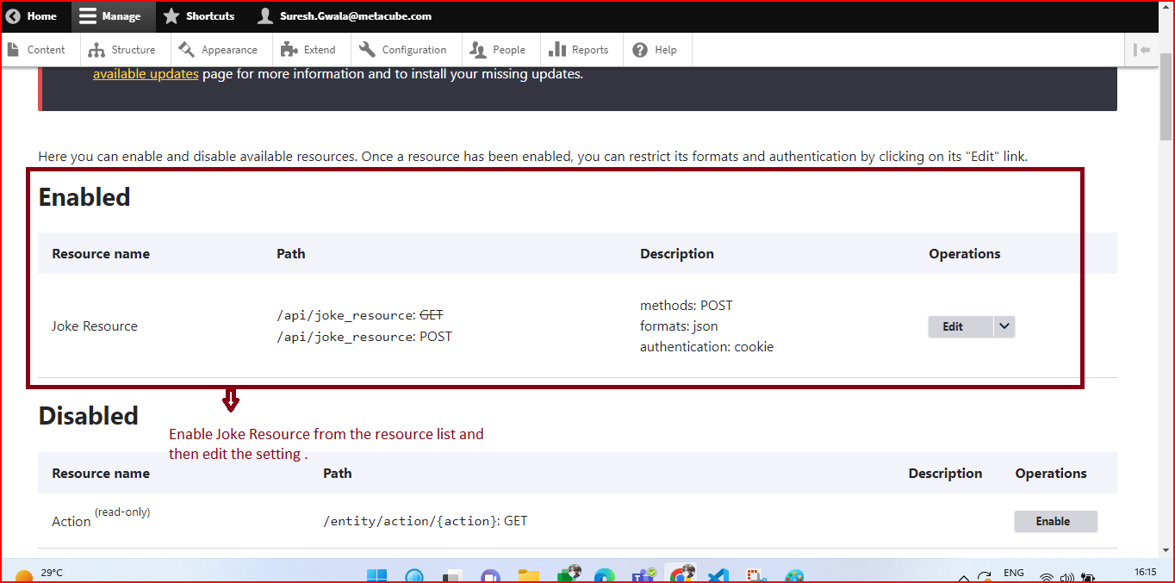

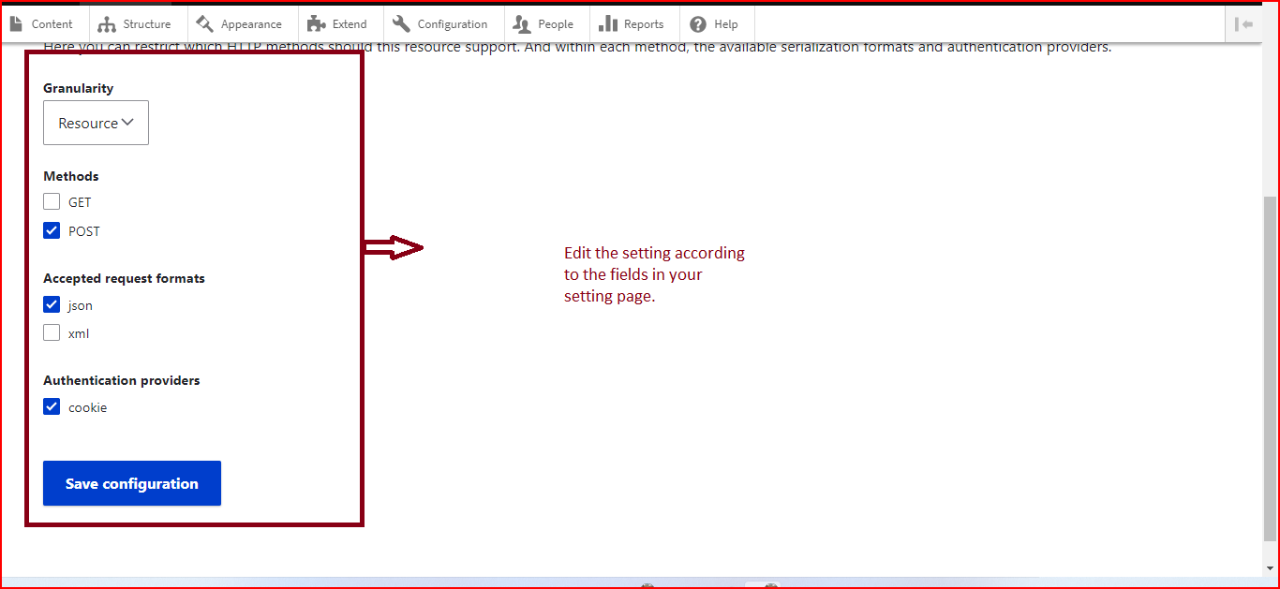

1. After enabling api options from drupal web service, We have to create a paragraph for the basic page which helps us to create your joke page.

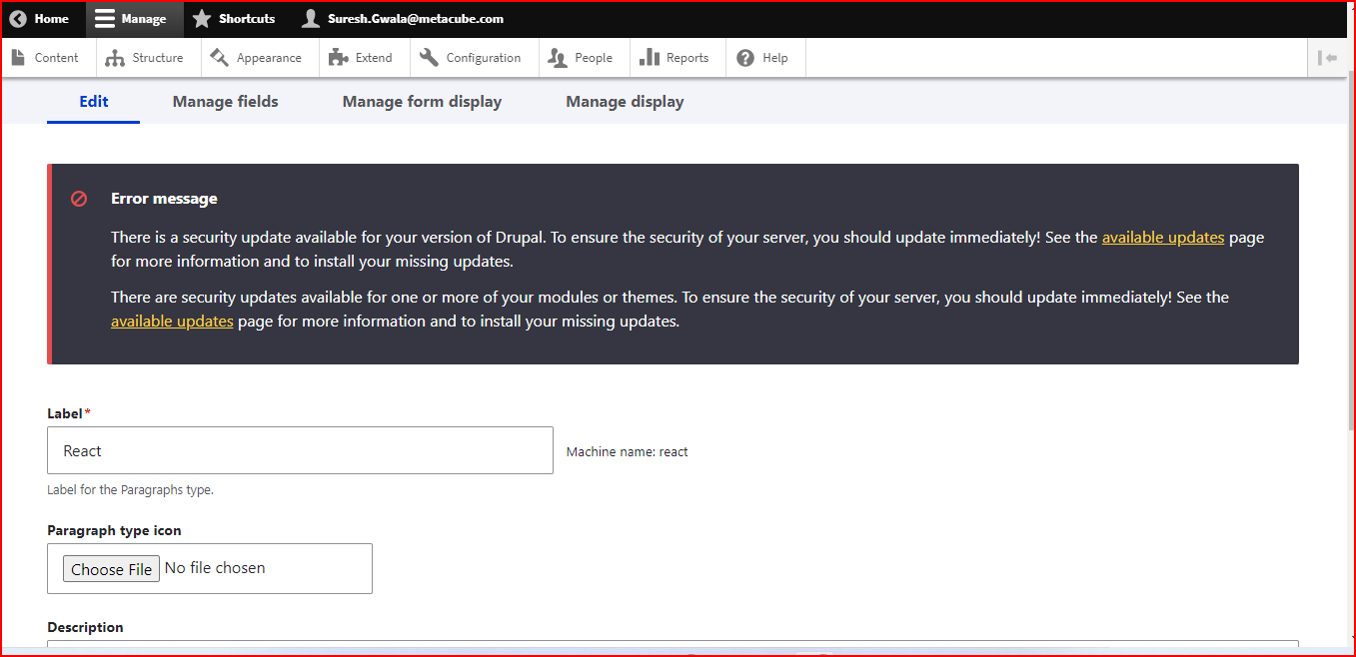

1. After creating a paragraph we have to create a paragraph file in theme for the given path ‘themes\site\templates\paragraphs’ and give the file name like ‘paragraph--react.html’. And you can get the paragraph file from given url - <https://drive.google.com/drive/folders/1wB2wrKozO_NQGp1yaKuQhn7V8FPGX-KI?usp=share_link>
2. After creating the paragraph we have to add that paragraph on body content type for showing on the paragraph list on basic page.

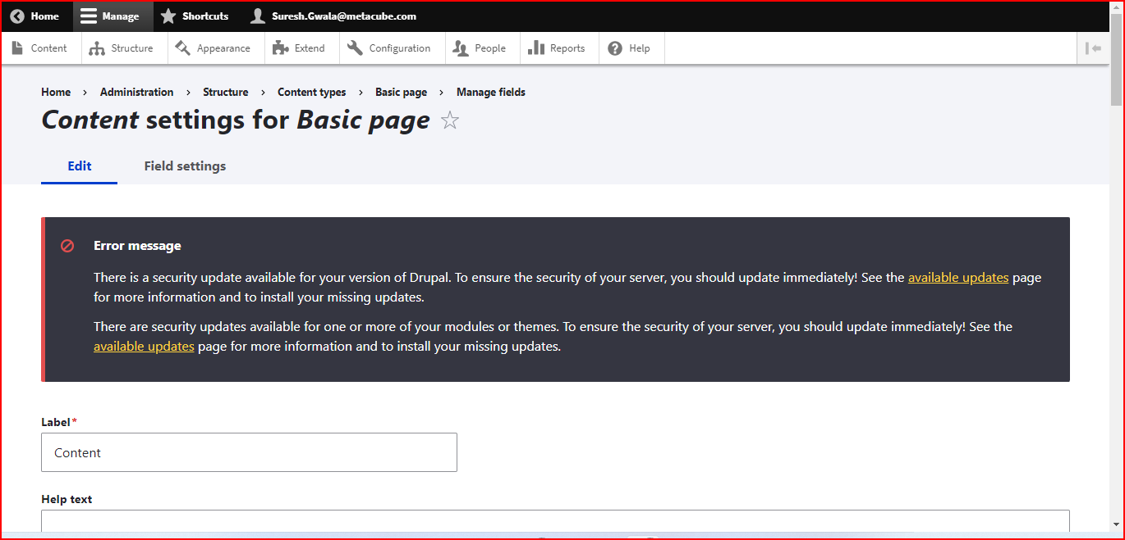

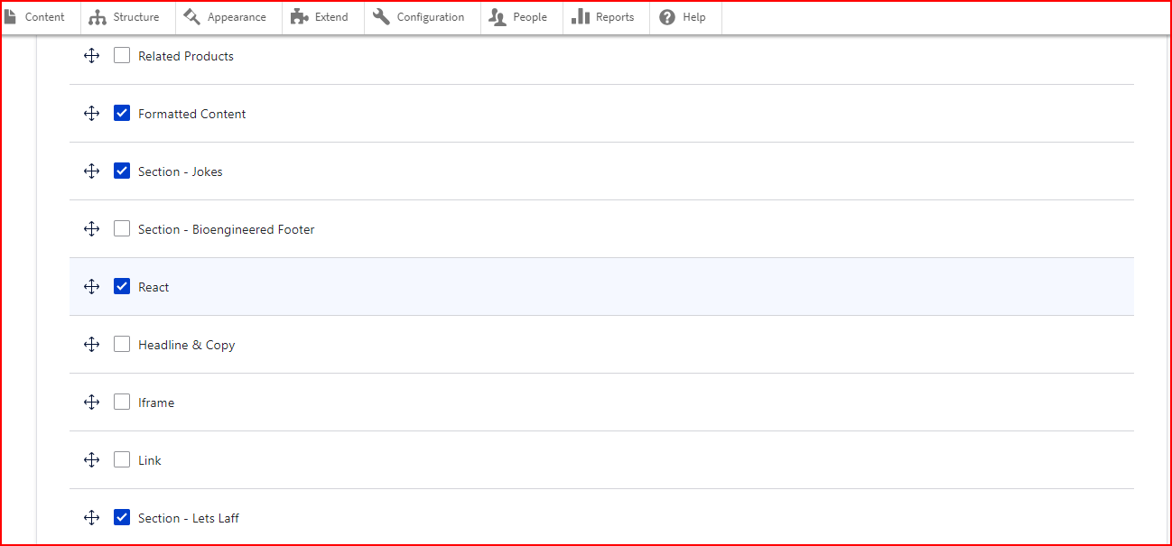

Note : In the above image react paragraph added for showing on basic page content.

1. After creating a paragraph successfully now you can create a basic page and you select the react paragraph for this page and you can view the html of the paragraph.

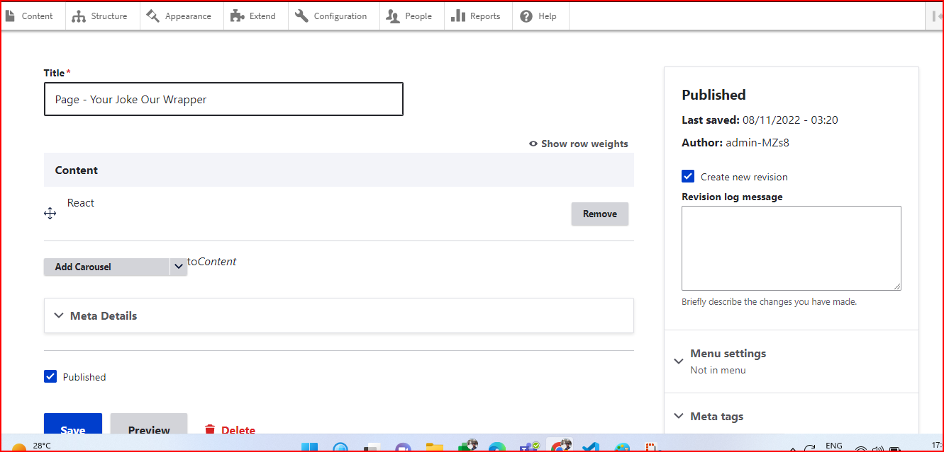

1. Once you create a basic page now we can add the js file and css file in the theme in the file structure path “\application\web\themes\site\js” and “\application\web\themes\site\css” respectively. The js and css file you can get from here - <https://drive.google.com/drive/folders/1wB2wrKozO_NQGp1yaKuQhn7V8FPGX-KI?usp=share_link>
2. After adding js and css files we have to add these files to the site.libraries.yml file for loading on the page.
3. After adding the css and js we have to add a static folder for theme file structure on path “\application\web\themes\site\dist\assets” for accessing images and csv files.
4. For showing up list of joke we have to add csv file in our theme folder with this path “/application\web\themes\site\dist\assets\static\files” and uploaded csv file which will we get from this link then download csv file from here and upload on given path - <https://drive.google.com/drive/folders/1wB2wrKozO_NQGp1yaKuQhn7V8FPGX-KI?usp=share_link>
5. When all the things are done then you can see the joke page looks like below screenshots.

